

Form5
Conclusion

Rossa Mobile Application for Smart
Attendance System

GROUP MEMBER:
No. | Student Name | Student ID
1. | Rich Edrick Anthonios | 012202300004
2. | Gilang Ruen Soekarno | 012202300042
3. | Dwi Wahyu Agustin | 012202300026

Advisor: Hadi Suprayitno, S.Kom., M.M

Submitted for
Capstone Design Project
to Faculty of Computer Science
President University
TABLE OF CONTENT

A. CONCLUSION AND FUTURE WORKS 5
1. Conclusion 5
2. Future Work 6
B. CLIENT FEEDBACK 8
1. Questionnaire Results 8
2. Client Comments and Recommendations 9
C. VIDEO DEMONSTRATION 10
1. How to build the system 10
2. How to install the system 10
3. How to use the system 10
REFERENCE 11

STATEMENT OF ORIGINALITY

In my capacity as an active student at President University and as the author of the Capstone Design Project stated below:
Name : 1. Rich Edrick Anthonios – 012202300004
2. Gilang Ruen Soe karno – 012202300042
3. Dwi Wahyu Agustin – 012202300026
Faculty : Computer Science
I hereby declare that my Capstone Design Project entitled “Rossa Mobile Application for
Smart Attendance System” is to the best of my knowledge and belief, an original piece of work based on sound academic principles. If there is any plagiarism detected in this final project, I am willing to be personally responsible for the consequences of these acts of plagiarism and will accept the sanctions against these acts in accordance with the rules and policies of President University.
I also declare that this work, either in whole or in part, has not been submitted to another university to obtain a degree.

Cikarang, 27 June 2026

Signer 1 | Signer 2 | Signer 3
 | 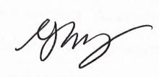 | 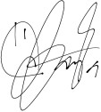
Rich Edrick  Anthonios –  012202300004 | Gilang Ruen Soekarno –  012202300042 | Dwi Wahyu Agustin –  012202300026

SCREENSHOT OF ZEROGPT

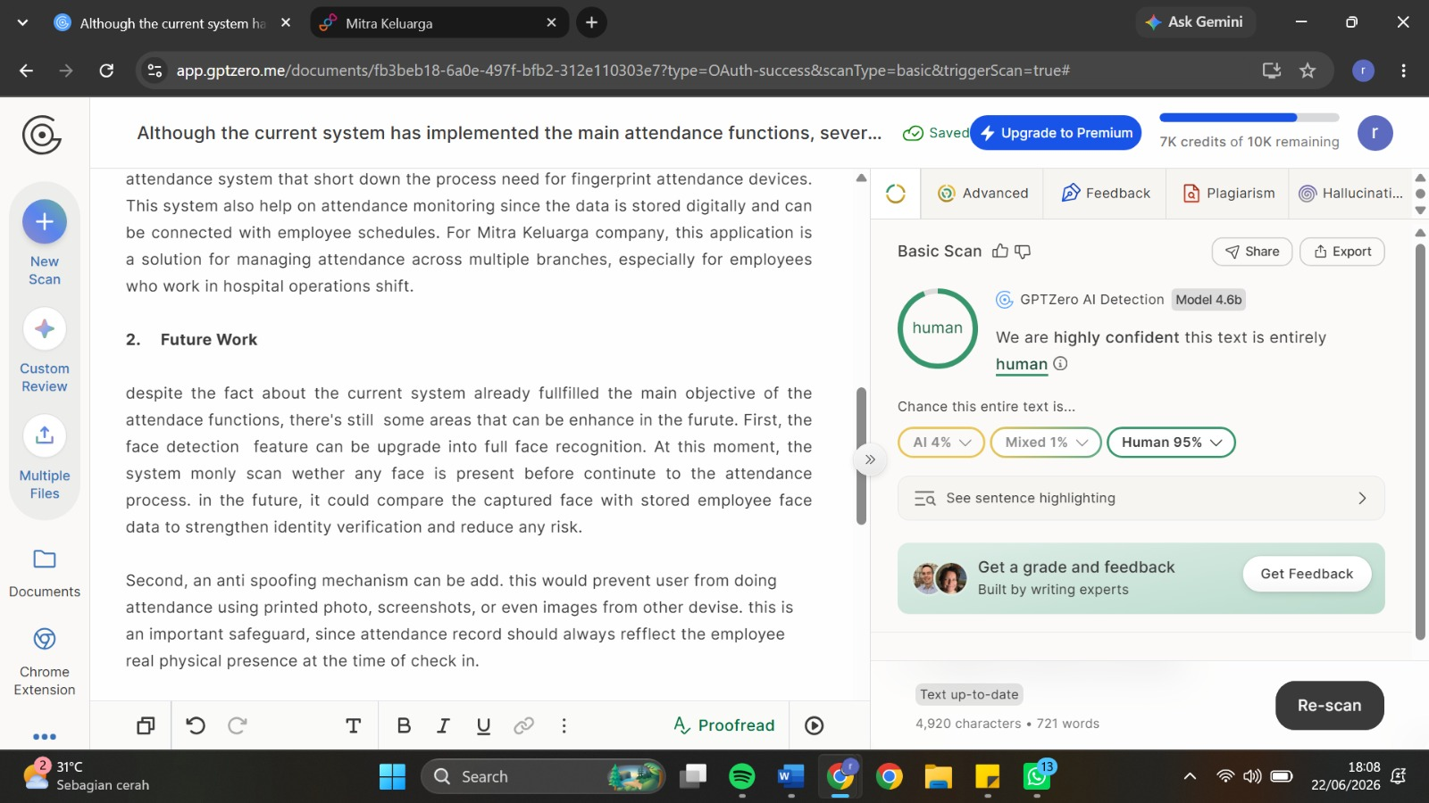

Rossa Mobile Application for Smart
Attendance System

Approved:

Hadi Suprayitno, S.Kom., M.M  Capstone Advisor | Ronny Juwono, S.Pd., M.T  Program Head of Informatics

Prof. Dr. Ir. Wiranto Herry Utomo, M.Kom.
Dean of Faculty of Computer Science

PART 5
CONCLUSION

A. CONCLUSION AND FUTURE WORKS

Conclusion
Rossa Mobile Application is a Smart Attendance System that is made for supporting the employee attendance process. The system helps the process in digital attendance with GPS location validation and taking a photo while doing clock in, clock out, and on call attendance. This way supports the attendance process so that employees can only do the attendance from the assigned hospital branches with proof of photo.
This system has several features such as user login, dashboard, GPS validation, face detection, clock in & clock out, on call attendance, attendance log, work schedule, supervisor assignment, profile information, admin, Mika AI. All these are connected to the Flutter mobile application, Golang backend, MongoDB database, OpenStreetMap service, Cloudinary image storage, Qdrant vector database, Gemini embedding, and Groq LLM API. All this integration is connected through the system so it's possible to record attendance, employee schedules, profile data, notification, and AI information support in one application.
The functional testing was going as planned, the main feature also worked according to our expectations. The login process, logout process, attendance submission, GPS validation, face detection, on call attendance, attendance log, supervisor schedule assignment, work schedule display, admin, Mika AI, and view profile features were tested using valid and invalid scenarios. The application accepted the valid inputs and rejected the invalid input, for example doing the attendance process outside the assigned hospital branch or photo verification without any face detected. By this testing scenario proves the application will support the basic digital attendance need for employees and supervisors need.
This project almost reaches the main objective by offering a mobile application attendance system that short down the process need for fingerprint attendance devices. This system also helps on attendance monitoring since the data is stored digitally and can be connected with employee schedules. For Mitra Keluarga company, this application is a solution for managing attendance across multiple branches, especially for employees who work in hospital operations shift.

Future Work
Despite the fact that the current system already fulfilled the main objective of the attendance functions, there are still some areas that can be enhanced in the future. First, the face detection feature can be upgraded into full face recognition. At this moment, the system only scans whether any face is present before continuing to the attendance process. In the future, it could compare the captured face with stored employee face data to strengthen identity verification and reduce any risk.
Second, an anti-spoofing mechanism can be added. This would prevent users from doing attendance using printed photos, screenshots, or even images from other devices. This is an important safeguard, since attendance records should always reflect the employee’s real physical presence at the time of check-in.
Third, the HR and management dashboard can be improved. The current condition of the system already supports the main objectives of attendance records, schedule viewing, and supervisor assignment. A more comprehensive dashboard is possible to be developed. This would help HR to view summaries by branch or even department, monitor employee status, track lateness and absences, and review on-call activity. With these insights, HR would be able to analyze attendance shortly and make wise decisions.
Fourth, scalability can be improved to support company-wide deployment. While Mitra Keluarga operates a lot of hospital branches with a large number of employees, the system needs stable and strong performance to handle it. This can be achieved with better database indexing, API optimization, and infrastructure improvements such as cloud deployment, load balancing, and system monitoring to ensure reliability under heavy usage.
Fifth, integration with the Human Resource Information System can be developed. In future development, attendance data could be connected to payroll, leave management, overtime, shift scheduling, and employee performance reports. This would help reduce data handling complexity and improve HR efficiency.
Sixth, Mika AI can be improved by expanding its knowledge. By including more internal documents such as HR policies, attendance rules, leave procedures, shift guidelines, and employee manuals, Mika AI could provide more accurate responses while reducing inquiries to HR.
Lastly, wider user acceptance testing can be conducted in all Mitra Keluarga branches, including employees and supervisors. This would help identify issues that the system has, branch-specific requirements, and technical issues that may not appear in smaller testing scope, enhancing the system to be ready before full deployment.

B. CLIENT FEEDBACK

Questionnaire Results
No | Evaluation Aspect | Average Score
1 | On Call feature functions properly and meets operational requirements | 4.25 / 5
2 | Clock In feature works accurately and is easy to use | 5.00 / 5
3 | Clock Out feature works accurately and is easy to use | 5.00 / 5
4 | Supervisor Assignment supports employee-supervisor coordination | 4.50 / 5
5 | Work Schedule displays work schedules clearly and accurately | 4.25 / 5
6 | AI Chatbot provides useful and relevant information when needed | 4.00 / 5
7 | Reminder Setting helps users remember attendance-related activities | 5.00 / 5
8 | Profile section displays employee information clearly and completely | 4.75 / 5
9 | Application interface is visually appealing and user-friendly | 5.00 / 5
10 | Overall satisfaction with the Attendance System Mobile Application | 4.75 / 5
 | Overall Average | 4.65 / 5

Client Comments and Recommendations

No | Respondent (Position / Department) | Comment / Recommendation | Avg. Score Given
1 | Hendi Wuryantoro  (IT Functional HCM) | Add a menu so employees can be assigned to clock in at any Mitra Keluarga branch. | 4.8 / 5
2 | Afrilia Kartika  (HR System / CHCD) | Improve On Call logic and night-shift (dinas malam) logic; add DWS to the dashboard. | 4.3 / 5
3 | Maftuh Zaidi  (IT Solution) | Add an admin menu to configure settings such as employee work locations and location polygon maps. | 4.5 / 5
4 | Oktavian Tyas Agung W  (HR System & Development) | Good job. | 5.0 / 5

Attachment: Client Feedback Questionnaire (PDF)

C. VIDEO DEMONSTRATION

How to build the system
How to build the system

How to install the system
How to install the system

How to use the system
How to use the system

REFERENCE

- Zhang, Z., & Constandinou, T. G. (2021b). A robust and automated algorithm that uses single-channel spike sorting to label multi-channel neuropixels data. A Robust and Automated Algorithm That Uses Single-channel Spike Sorting to Label Multi-channel Neuropixels Data, 783–787. https://doi.org/10.1109/ner49283.2021.9441234
- Hundesa, T., Lemecha, L., & Koya, P. R. (2019b). One-Dimensional explicit Tolesa numerical scheme for solving first order hyperbolic equations and its application to macroscopic traffic flow model. Applied Mathematics, 10(03), 119–137. https://doi.org/10.4236/am.2019.103011
- Dhandapani, V., Majji, S., Udata, K., & Manigandan, M. (2021). Implementation of attendance management system based on text and face recognition. In Lecture notes in electrical engineering (pp. 55–68). https://doi.org/10.1007/978-981-16-1476-7_7

